How to setup winBGIm library in codeblock
BGI (Borland Graphics Interface) is ancient as is turbo c++ IDE but nevertheless they are still used in our schools and colleges. Plus they do not work in windows environment (support for native DOS has been completely removed in windows vista/7).If you try to compile the source code with including “graphics.h” in code::blocks IDE then is show error because “graphics.h” only run in turbo.For code::blocks you have to setup winBGIm library.
There are many alternative to winBGIm ,But BGI is good for beginners because you don’t have to worry about whole new fancy functions,classes etc.
WinBGIm is BGI graphics library ported to computer by by Michael Main at the University of Colorado.
Before i start, i must tell you that this guide is written in accordance with code::blocks IDE.
Lets get started:
- First download WinBGIm from http://winbgim.codecutter.org/
- Extract it.
- Copy graphics.h and winbgim.h files in include folder of your compiler directory
- Copy libbgi.a to lib folder of your compiler directory
- In code::blocks open Settings >> Compiler and debugger >>linker settings
- click Add button in link libraries part and browse and select libbgi.a file
- In right part (ie. other linker options) paste commands
-lbgi -lgdi32 -lcomdlg32 -luuid -loleaut32 -lole32
- click Ok
Finally, you can now compile source code using “graphics.h”.You can try this by creating "anlog clock" and you can copy source code from my post here . The WinBGIm library gives you an alternative as I hope, you found this guide helpful and in case you need my help just leave a message.

**While compiling if you got error message in line 320 of graphics.h :” redefination of int right” then change int right=0 to int top = 0.Although,you got other error then leave the message.

Setup OpenGL(glut) in code::block

TO create OpenGL/GLUT Project in code::block,at first you have to download the glut libary from this website http://www.opengl.org/resources/libraries/glut/glut_downloads.phpfor windows.
Lets create GLUT project
step 1:
first unzip the zip file
step 2:
copy the glut.h file from the include folder of unzip file of step 1
and paste to the folder "C:\Program Files\CodeBlocks\MinGW\include\GL" again copy all file from the lib folder of unzip file of step 1
and paste to the folder "C:\Program Files\CodeBlocks\MinGW\lib"
also copy the glut.dll file from the bin folder of unzip file and paste it
inside "C:\Windows\System32" folder.

step 3:
Open the code block you will see window as below and click on create new
porject link

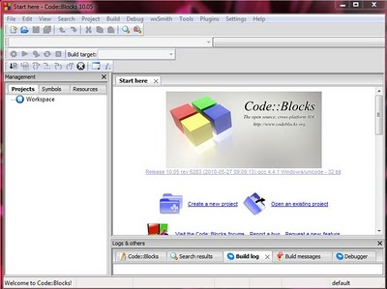
step 4:
click on GLUT project as shown in image below
click next
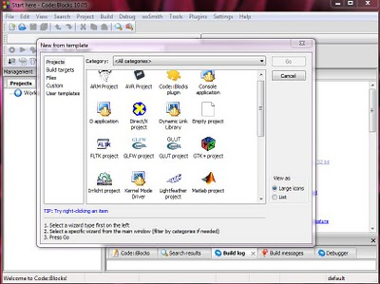
write project title name ,give path to save project and write projec filename will create by default from project title name.
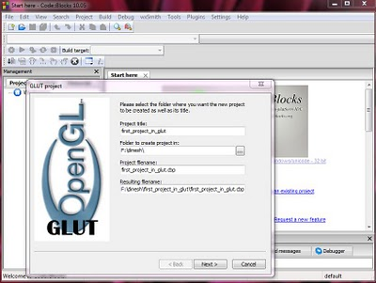
After that click next.
step 5:
now give the path "C:\Program Files\CodeBlocks\MinGW" for glut location
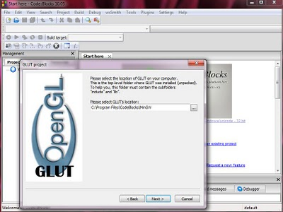
Then click next.
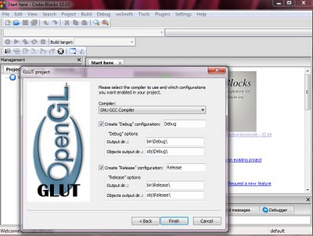

Now click finish
step 6:
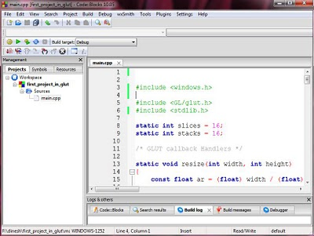
now you see the project is created and you will get default main.cpp file don't forget to write "#include<windows.h>" header file otherwise you will get error now built and run it will see window as below.
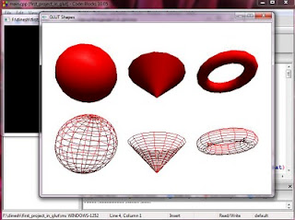
your project is created you can write your own code.

Creating multiple windows with OpenGL and GLUT

We may need the multiple OpenGL windows for our program for example we can show orthographic view of object (top view, side view,front view) in separate windows.
Steps for Creating Multiple Windows:-
1.Initialize drawing context and frame buffer using glutInit(), glutInitDisplayMode(), and glutInitWindowSize().
2.Create first window
3.Register callbacks for first window
4.Create second window
5.Position the second window
6.Register callbacks for second window
7.Register (shared) idle callback
8.Enter the main loop

Note: Callbacks can be shared between windows, if desired

Creating a Window:-
int glutCreateWindow(char *name);
Creates a window data structure and returns a small integer identifier.
Window is not displayed until the main loop is entered
Window becomes the current window. The current window
Can be set or obtained using glutSetWindow() and glutGetWindow().

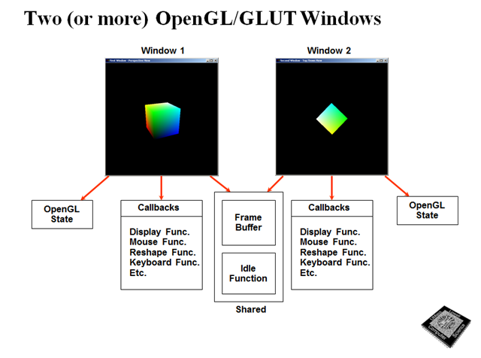

Here is the example with complete source code. This code is compiled in codeblocks IDE and gcc compiler and also don’t forget to setup OpenGL for codeblocks to run this code.

//www.codeincodeblock.blogspot.com

#include<windows.h>

#include <GL/glut.h>

#include <stdlib.h>

using namespace std;

void handleKeypress(unsigned char key,int x,int y)

{

switch(key)

{

case 27:

exit(0);

}

}

void initRendering()

{

glEnable(GL_DEPTH_TEST);

}

void handleResize(int w,int h)

{

glViewport(0,0,w,h);

glMatrixMode(GL_PROJECTION);

gluPerspective(45.0,(double)w/(double)h,1.0,200);

}

void drawScene1()

{

glClear(GL_COLOR_BUFFER_BIT|GL_DEPTH_BUFFER_BIT);

glMatrixMode(GL_MODELVIEW);

glLoadIdentity();

glBegin(GL_QUADS);

glVertex3f(0.0f,0.0f,-5.0f);

glVertex3f(0.0f,1.0f,-5.0f);

glVertex3f(1.0f,1.0f,-5.0f);

glVertex3f(1.0f,0.0f,-5.0f);

glEnd();

glutSwapBuffers();

}

void drawScene2()

{

glClear(GL_COLOR_BUFFER_BIT|GL_DEPTH_BUFFER_BIT);

glMatrixMode(GL_MODELVIEW);

glLoadIdentity();

glBegin(GL_QUADS);

//rectangle

glVertex3f(0.0f,0.0f,-5.0f);

glVertex3f(0.0f,1.0f,-5.0f);

glVertex3f(1.0f,1.0f,-5.0f);

glVertex3f(1.0f,0.0f,-5.0f);

glEnd();

glutSwapBuffers();

}

int main(int argc,char** argv)

{

glutInit(&argc,argv);

initRendering();

glutInitDisplayMode(GLUT_DOUBLE|GLUT_RGB|GLUT_DEPTH);

glutInitWindowSize(500,500);

//window1=

glutCreateWindow("First window :-www.codeincodeblock.blogspot.com");

glutDisplayFunc(drawScene1);

glutKeyboardFunc(handleKeypress);

glutReshapeFunc(handleResize);

//create the second window

//window2 =

glutCreateWindow("Second Window :www.codeincodeblock.blogspot.com");

//define a window position for second window

glutPositionWindow(540,40);

// register callbacks for second window, which is now current

glutReshapeFunc(handleResize);

glutDisplayFunc(drawScene2);

glutKeyboardFunc(handleKeypress);

glutMainLoop();

return 0;

}

